21.40: Point charges 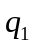 (0.500 nC) and 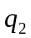 (8.00 nC) are separated by 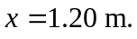 The electric field is zero when
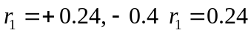 is the point between.

